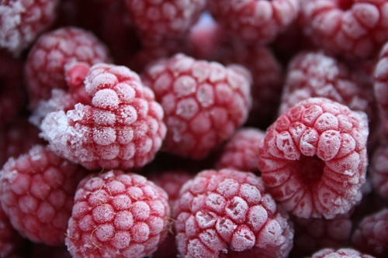



**Project Objectives:**

* To learn how to safely freeze foods to maintain top quality.
* To learn how to use frozen foods you prepared in healthy recipes.
* To show others how to preserve foods by freezing.

**4-H members will learn:**

* Freezing food basics.
* Methods for freezing fruits, juices, vegetables, meats and convenience foods.
* Proper packaging, freezing and thawing your product safely.
* How to create a freezer inventory.
* How to create a menu plan for food from your freezer.

**To complete this project:**

* Review the 4-H Food Preservation Freezing Project Manual and the Greentop to become familiar with the project.
* Successfully complete the freezing of fruit, juice, vegetables and convenience foods, as listed in the project record book.
* Prepare and give a demonstration or illustrated talk at club meetings or 4-H contests
* Participate in the county and state fairs by entering at least one of the following:
  + Create a “Home freezer inventory record (8 ½” x 11”).
  + Make a “Menu Plan” for 3 meals, using frozen foods from your freezer inventory (8 ½” x 11”).

**Resources:**

• Freezing Project Book – 100.E-10

• Foods Record Sheet 300.A-20 (R-18)

**Citizenship and Leadership Activities:**

* Volunteer your time to help someone in your area with defrosting their freezer and making a freezer inventory.
* Volunteer to help someone in your area with gardening and growing fresh produce.
* Consider making baked goods and freezer jam to share with someone in need.
* Make a freezer meal for someone who has just had a new baby or has been ill.
* Give a presentation or illustrated talk at a club meeting.
* Assist younger 4-H members with this project.
* Encourage other 4-H members to enroll in this project.

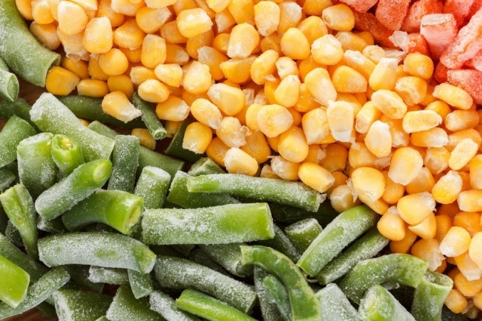

Moyers,2014